FRAMEWORK FOR RECOMMENDATION SYSTEM

Asmitha Gurung-19BTRCR058
Bandana Rawal-19BTRCR059
Emranul Haque Raque-19BTRCR060
Nishen Ganegoda-19BTRCR061

Abstract:
A recommender system (RS) is a type of information system that makes recommendations. Its goal is to provide the most relevant goods (music, movies, etc.) to each user. Several recommendation algorithms have been proposed in the literature, and to determine the optimal method, a comparison of their experimental outcomes is required. This paper lays out a framework for presenting, developing, and evaluating ideas as well as testing and reviewing a recommender system We believe that this technique has the potential to be extremely useful in the development of architecture and design. This type of system's implementation. The proposed model depicts the process of preparing a data set, whether it is for rating or for analysis of data from the social world It also comes with a set of cutting-edge algorithms. The capability of our architecture is its uniqueness. Establishing four types of basic recommender systems.
Keywords:
Recommender System, Framework, Architecture, Social, Contextual, Socio-contextual.

Introduction:

The massive amount of data about users available in social networks is prompting researchers to include it into their studies in recommendation engines (RS). The quality of suggestions has improved as a result of the value of this data, which can be primarily social and contextual. Users who could be interested in these suggestions are offered item suggestions (product, song, film, etc.) by RS. These systems are influenced by the preferences of users when making recommendations. designing four different types of recommender systems: basic, social, contextual, and socio-contextual.
Users’ preferences, which have historically been based on users’ historical evaluations of things, have been updated in recent works to include social and contextual information.
This study presents a conceptual framework with a practical architecture to help clarify the entire recommendation process and make it easier to implement. Because there are numerous ways to recommendation, a unifying framework is required not only to collect these approaches, but also to interpret them within the given framework. Furthermore, this system should be able to display a variety of input data. In reality, the input structure distinguishes the many types of recommendation algorithms. The social recommendation algorithm, for example, combines social information and rating data as input, whereas the contextual recommendation algorithm employs contextual information based on rating data as input. The discrepancy has a significant impact on data representation and, as a result, the recommendation process.

Background:

Research content;

Generally, a RS can be classified into three distinct classes: there are content based, collaborative filtering and hybrid-based approaches. However, the most widely used technique to build a RS is collaborative filtering. According to this model, user’s interactions on items are stocked on a matrix called rating matrix, noted 𝑅. It involves 𝑚 users and 𝑛𝑛 items. Each column represents a user 𝑖, each row represents an item 𝑗, and each cell 𝑟_{i j} corresponds to the evaluation of user 𝑖 on item 𝑗. Traditionally, classical recommender system approaches use existing interactions of users to predict missing evaluations, in order to propose recommendations that satisfy each user. With the advent of social networks, researches have use as input social information in addition to the rating matrix to build social recommender systems. This information consists of calculating similarities among all users, according to a specific metric. In recent years, researches have integrated context information into RS in view of its importance. According to, context is defined as “any information that can be used to characterize any entity”. Consequently, context-aware recommender system is built. Other’s research has investigated social and contextual information in their work to build socio-contextual based approach. These four types of recommendations, named basic, social, contextual and socio-contextual have been well developed in the past decade. In the next sub-section, we concentrate on the basic motivating scenario and goals of this work.

Related work;

We situate our research in the area of recommender systems. We focus on approaches using classical, social and contextual information and especially concentrate on recent implementations of these different proposed models. EasyRec is a special implementation designed for web applications, which provides the implementation of classical recommendation approaches, but it was not updated since its latest release. Lenskit is a java recommendation library that only provides the implementation of classical algorithms of recommendations, such as user and item based, KNN collaborative filtering, matrix factorization and slope one recommender. LibRec is a modern java-based recommender algorithm that is specifically designed for social aware recommendation algorithm in addition to those classical one. Carskit is a java-based context aware recommendation which implements the state of art contextual algorithm. The first work, entitled LibRec, Abbreviation of Library for Recommender system, is oriented to social recommender algorithms, whereas the second one, called CarsKit, abbreviation of Context aware Recommender system is depicted for contextual recommender algorithms. Unfortunately, no recommendation framework has embedded all those algorithms in their library, due to the special characteristics of the data format and the difference in the process of methods. The specification of our proposed framework is its capability to encompass these different existing works into one, in a manner that these existing implementations can be reused in one architecture, which is not considered in existing works. In the other hand, our proposed framework encapsulates the concept of similarity calculating amongst users, which is not considered in recent works.

Framework description:

The primary objective of this work is to contribute to recommender system design by proposing a framework that clarify the principles of a recommender system and details each step. A general structure of a recommendation algorithm was proposed by15. This process described in our last work is very general and details about input data and recommendation algorithm are not well defined. The proposed conceptual framework (see Fig.1) contains three parts: (1) Input Data (2) Algorithm of recommendation (3) Output. The proposed framework can serve to gather different proposed approach of recommendation, build simplified and effective architecture, and put forward practical ideas for further implementation. These three parts of recommendation process are defined in the next three sub-sections.

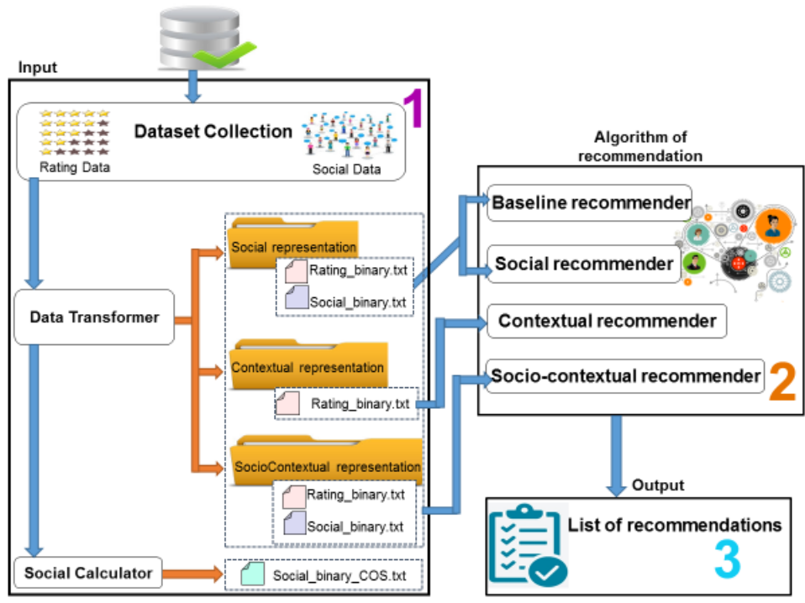

Input Data;

According to above figure Input Data is as well divided into three steps:
- Dataset collection
- Data transformer
- Social Calculator
Dataset collection refers to the selected dataset. The selected dataset must contain rating data, which refers to “users, items, user ratings”. Other than rating data, we can find social data. Depending on the selected dataset, the representation of data is different. Whatever the representation of the selected data, a module for data transformer converts it to one among three common representations: social representation, contextual representation and socioContextual representation.

Algorithms;

Existing works in recommender system algorithms can be classified, according to the input data, into four types of algorithms: there are baselines, social based, contextual and socioContextual based approaches. Baselines uses as input ratings of users to items according to social representation. Social based recommender system uses other than rating data, social information according to social representation and contextual based recommender system uses contextual data according to contextual representation. Finally, socioContextual recommender uses rating data and social data according to socioContextual representation.

Output;

Generally, the output of a recommender system consists of a list of recommendations for users according to their preferences in the past.

Architecture

In the present paper, we propose LibSCars, Library for social Context-aware recommender systems. It offers a flexible architecture to reuse existing works in recommender systems, choose specific similarity measure and provides spaces to implements socioContextual algorithm in the future. The workflow of our proposed architecture, which is an extension of architectures presented, can be depicted by the below figure.

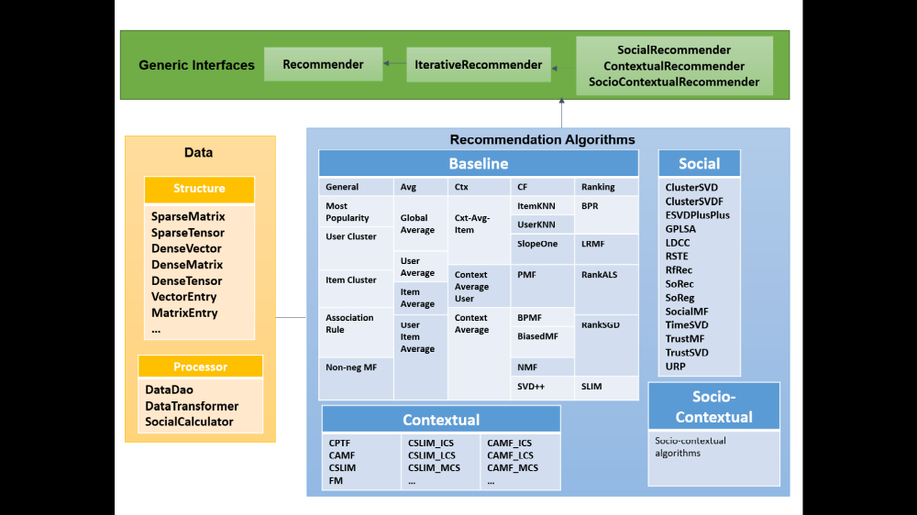

Generic Interfaces;

A set of abstract recommenders that can be extended by another algorithm of recommendation are defined as generic interfaces. Four generic interfaces known as Recommender, IterativeRecommender, ContextRecommender, SocialRecommender and SocialContextualRecommender are implemented. Recommender is a general recommender which can be extended by baselines. IterativeRecommender is based on iterative learning techniques. SocialRecommender and ContextRecommender are extended by algorithms that use respectively social and contextual information. And finally, Socio-contextual recommender is an additional generic interface proposed in this paper to be extended by algorithms that use at the same time social and contextual data.

Data Structure;

Data are divided into Data structure and data processor. In one hand, data structure defines SparseMatrix, SparseVector, DenseMatrix, DenseVector, SymmetricMatrix and DiagonalMatrix., SparseTensor, TensorEntry, MatrixEntry and VectorEntry. In the other hand, data processor concerns DataDao, DataSplitter and DataTransformer. DataTransformer converts a data sets format into another one. We propose here to implement SimilarityCalculator, which consists of calculating similarity measure among users.

Recommendation Algorithms;

Algorithms presented in the above given figure can be summarized as follows:
- General baseline recommender: Most Popularity, User Cluster16, Item Cluster, Association Rule.
- Baseline based Average recommender: Global Average, User Average, Item Average, User Item Average.
- Baseline based collaborative filtering: Item KNN, User KNN, Slope One, PMF, BPMF, Biased MF, NMF, SVD++5.
- Baseline based context recommender: Context Average, Item Context Average, User Context Average.
- Social-contextual recommender systems: algorithm using social and contextual information. LibSCars provides spaces to develop new socio-contextual algorithms in the future.

Implementation and experiments

We implemented a library to perform all these tasks. This work is directed by means of the JAVA programming language according to the proposed framework and based on the LibSCars architecture. We now introduce the different instructions about how to use our implementation, that’s mean how to transform rating data, construct social similarity file according to a specific metric, choose an algorithm, and evaluate it by LibSCars.

- Dataset Transformation (Pending)

- Data Format (Pending)

- Data Preparation (Pending)

- Algorithm Interpretation (Pending)

- Experimental Configuration (Pending)

Conclusion

In this paper, a conceptual framework for building a recommender system is presented. Also, we have presented a flexible architecture of LibSCars. Accordingly, a practical implementation is well defined. LibSCars contributes to the area of recommender systems to afford;
- Efficient data transformer whether rating or social data
- easy social similarity calculator;
- Including the implementation of a set of existing state-of-the-art algorithm. The specificity here is the diversity of recommendation algorithm types, which are; baselines, social and contextual recommenders. So, it is easy to compare among different algorithms;
- providing space to develop socio-contextual recommender algorithms. In future, we will implement algorithms based on socio-contextual approaches. It is also interesting to add the possibility of computing similarity metrics among users.

References

- Designing Recommender System Conceptual Framework from:International Conference on Knowledge Based and Intelligent Information and Engineering Systems, KES2017, 6-8 September 2017, Marseille, France.
- A. K. Dey. Understanding and using context. In: Personal and Ubiquitous Computing, vol. 5; 2001.p. 4-7.
- D. E. Michael, L. Michael, A. K. Joseph and T. R. John. Rethinking the Recommender Research Ecosystem: Reproducibility, Openness, and LensKit. In: fifth ACM conference on Recommender systems (RecSys'11). Chicago, Illinois, USA; 2011.p. 133-140.
- G. Guibing, Z. Jie, S. Zhu and Y.-S. Neil. LibRec: A Java Library for Recommender Systems. In 23rd Conference on User Modelling, Adaptation and Personalization (UMAP); 2015.
- Z. Yong, M. Bamshad and D. B. Robin. CARSKit: A Java-Based Context-aware Recommendation Engine. In 15th IEEE International Conference on Data Mining (ICDM); 2015.p. 1668-1671.
- K. Yehuda. Factorization meets the neighborhood: a multifaceted collaborative filtering model. In 14th ACM SIGKDD international
- G. Guibing, Z. Jie and Y.-S. Neil. TrustSVD: Collaborative Filtering with Both the Explicit and Implicit Influence of User Trust and. In Twenty-Ninth AAAI Conference on Artificial Intelligence. Austin, Texas; 2015.p. 123-129.
- L. Baltrunas, L. Bernd and R. Francesco. Matrix factorization techniques for context aware recommendation. In fifth ACM conference on Recommender systems (RecSys). Chicago, Illinois, USA; 2011.p. 301-304.
- S. Rendle, Z. Gantner, C. Freudenthaler and L. Schmidt-Thieme. Fast context-aware recommendations with factorization machines. In 34th international ACM SIGIR conference on Research and development in Information Retrieval (SIGIR). Beijing, China; 2011.p. 635-644.
- N. Xia and K. George. SLIM: Sparse Linear Methods for Top-N Recommender Systems. In 11th IEEE International Conference on Data Mining (ICDM). Canada; 2011.p. 497-506

